문제해결기법(13967005)

202135592 한웅재

소프트웨어

제출일: 2021. 9. 17

Chapter 7.3 Exercises

2.

#define _CRT_SECURE_NO_WARNINGS// or scanf_s

#include <stdio.h>

#include <math.h>

#include <stdlib.h>

#include <string.h>

#include <time.h>

#include <ctype.h>

void change(float cash,int *quarters,int* dimes, int *nickels, int *pennies);

int main() {

float cash[] = { 15.33f,0.79f,2134.0f,65.45f,0.33f,45.58f,1.99f };//rounding error

int quarters=0, dimes=0, nickels=0, pennies=0;

int test_num = 7;

for (int i = 0; i < test_num;i++) {

quarters = 0, dimes = 0, nickels = 0, pennies = 0;

change(cash[i], &quarters, &dimes, &nickels, &pennies);

printf("-----test_num_%d-----\n", i + 1);

printf("Cash %0.2f Change --> %d quarters, %d dimes, %d nickels, %d pennies\n", cash[i], quarters, dimes, nickels, pennies);

}

return 0;

}

void change(float cash, int* quarters, int* dimes, int* nickels, int* pennies) {

double cents;

cents = floor(((cash - floor(cash))*100.0f)+0.5);

while (cents != 0) {

if (cents >= 25) {

cents -= 25;

(*quarters)++;

}

else if (cents<25&&cents>=10) {

cents -= 10;

(*dimes)++;

}

else if (cents<10&&cents>=5) {

cents -= 5;

(*nickels)++;

}

else if (cents<5) {

cents -= 1;

(*pennies)++;

}

}

}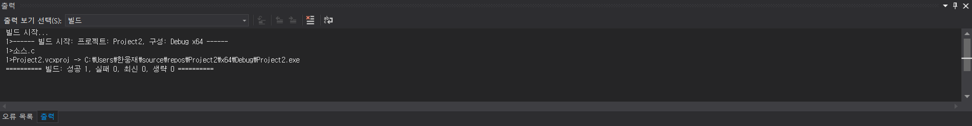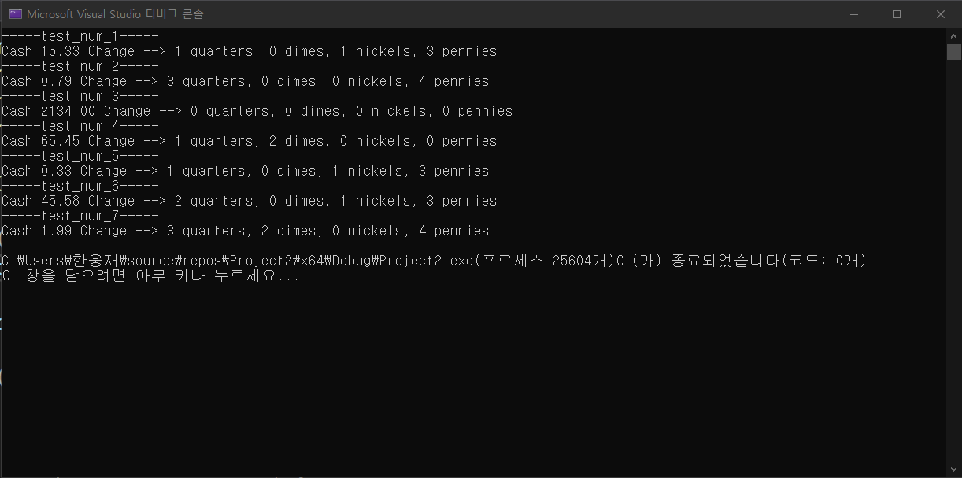

3a.

#define _CRT_SECURE_NO_WARNINGS// or scanf_s

#include <stdio.h>

#include <math.h>

#include <stdlib.h>

#include <string.h>

#include <time.h>

#include <ctype.h>

int secs(int hours,int mins, int ss);

int main() {

int hours[] = {1,0,0,2,0};

int mins[] = {30,0,0,0,10};

int ss[] = {30,0,3,0,0};

int test_num = 5;

int total_secs = 0;

for (int i = 0; i < test_num; i++) {

total_secs = secs(hours[i], mins[i], ss[i]);

printf("---test_num_%d---\n", i + 1);

printf("%d hours %d minutes %d seconds --> %d seconds\n", hours[i], mins[i], ss[i], total_secs);

}

return 0;

}

int secs(int hours, int mins, int ss) {

int total=0;

total += hours * 3600;

total += mins * 60;

total += ss;

return total;

}

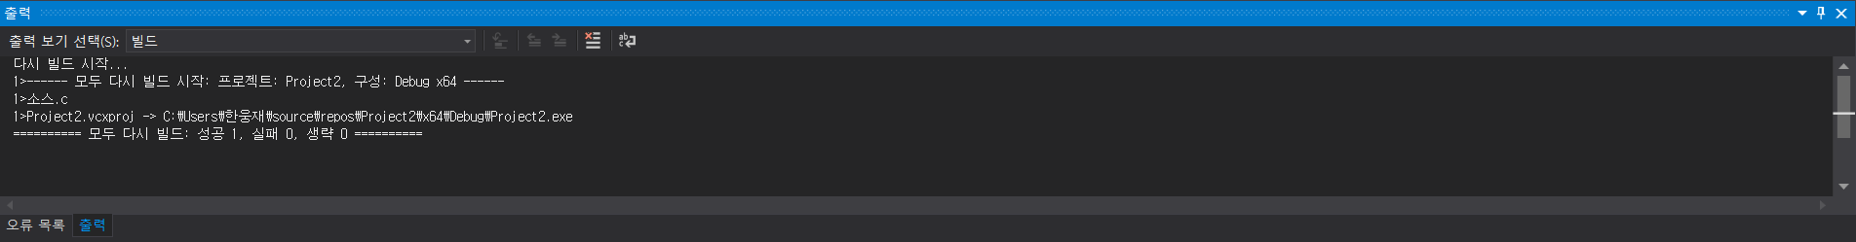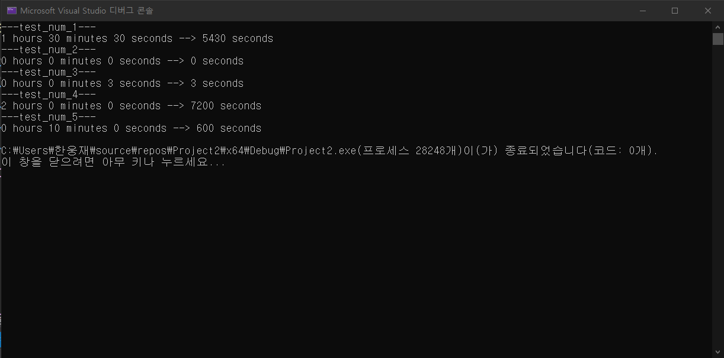

3b.

#define _CRT_SECURE_NO_WARNINGS// or scanf_s

#include <stdio.h>

#include <math.h>

#include <stdlib.h>

#include <string.h>

#include <time.h>

#include <ctype.h>

void secs(int *totSec,int hours,int mins, int ss);

int main() {

int hours[] = {1,0,0,2,0};

int mins[] = {30,0,0,0,10};

int ss[] = {30,0,3,0,0};

int test_num = 5;

int totSec = 0;

for (int i = 0; i < test_num; i++) {

totSec = 0;

secs(&totSec,hours[i], mins[i], ss[i]);

printf("---test_num_%d---\n", i + 1);

printf("%d hours %d minutes %d seconds --> %d seconds\n", hours[i], mins[i], ss[i], totSec);

}

return 0;

}

void secs(int *totSec,int hours, int mins, int ss) {

*totSec += hours * 3600;

*totSec += mins * 60;

*totSec += ss;

}

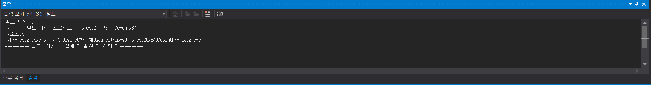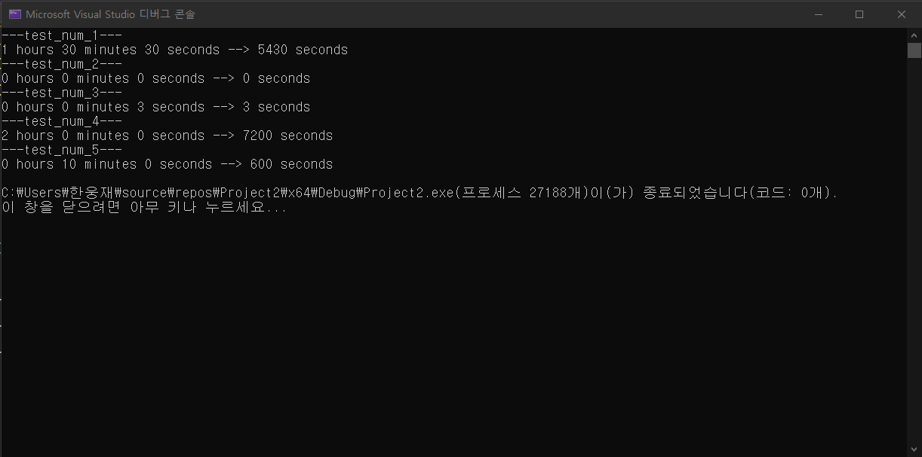

Textbook Chapter 9.4

Programming Exercise #2

#define _CRT_SECURE_NO_WARNINGS// or scanf_s

#include <stdio.h>

#include <math.h>

#include <stdlib.h>

#include <string.h>

#include <time.h>

#include <ctype.h>

void liquid(int totCup, int* gallons, int* quarts, int* pints, int* cups);

int main() {

int totCup[] = { 24,15,17,3,5,1,2,130,0 };

int test_num = 9;

int gallons, quarts, pints, cups;

for (int i = 0; i < test_num; i++) {

gallons = 0, quarts = 0, pints = 0, cups = 0;

liquid(totCup[i], &gallons, &quarts, &pints, &cups);

printf("-----test_num_%d-----\n", i + 1);

printf("total cups : %d --> %d gallons, %d quarts, %d pints, %d cups\n", totCup[i], gallons, quarts, pints, cups);

}

return 0;

}

void liquid(int totCup, int* gallons, int* quarts, int* pints, int* cups) {

//pint= 2 cups

//quart= 4 cups

//gallon = 16 cups

*gallons = (int)ceil((double)totCup / 16.0);

*quarts = (int)ceil((double)totCup / 4.0);

*pints = (int)ceil((double)totCup / 2.0);

*cups = totCup;

}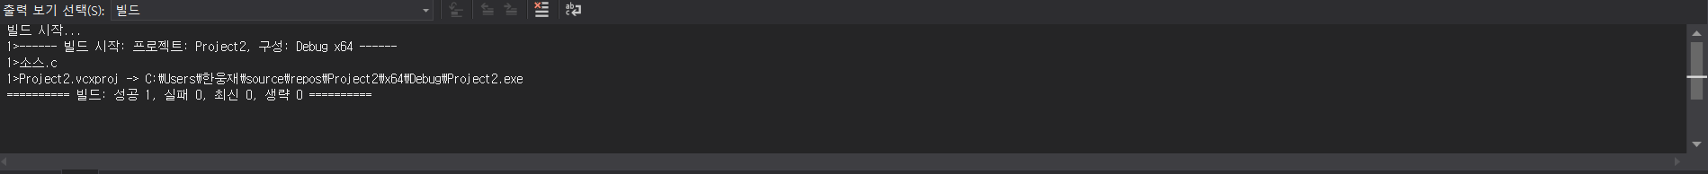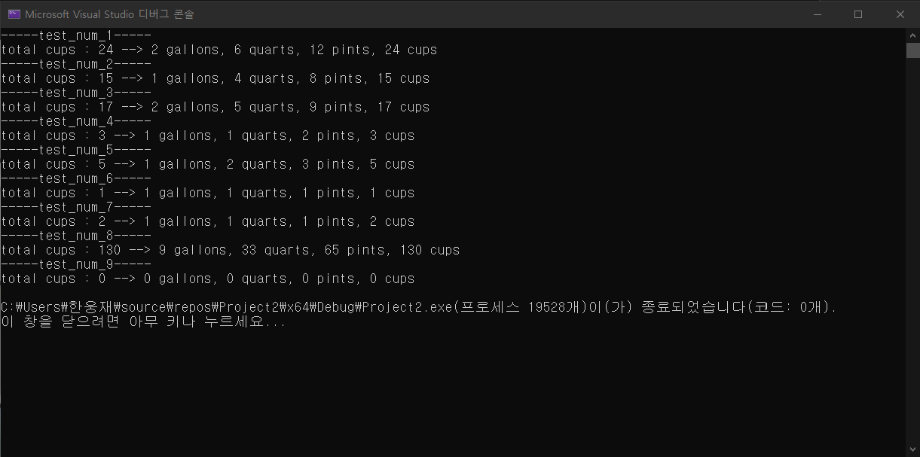

Textbook Chapter 8.3

Programming Exercises 2

#define _CRT_SECURE_NO_WARNINGS// or scanf_s

#include <stdio.h>

#include <math.h>

#include <stdlib.h>

#include <string.h>

#include <time.h>

#include <ctype.h>

void show(double rates[]);

int main() {

double rates[] = {6.5, 8.2, 8.5, 8.3, 8.6, 9.4, 9.6, 9.8, 10.0};

show(rates);

return 0;

}

void show(double rates[]) {

for (int i = 0; i < 9; i++) {

printf(" %.1lf ", rates[i]);

}

}

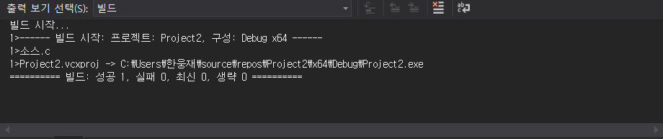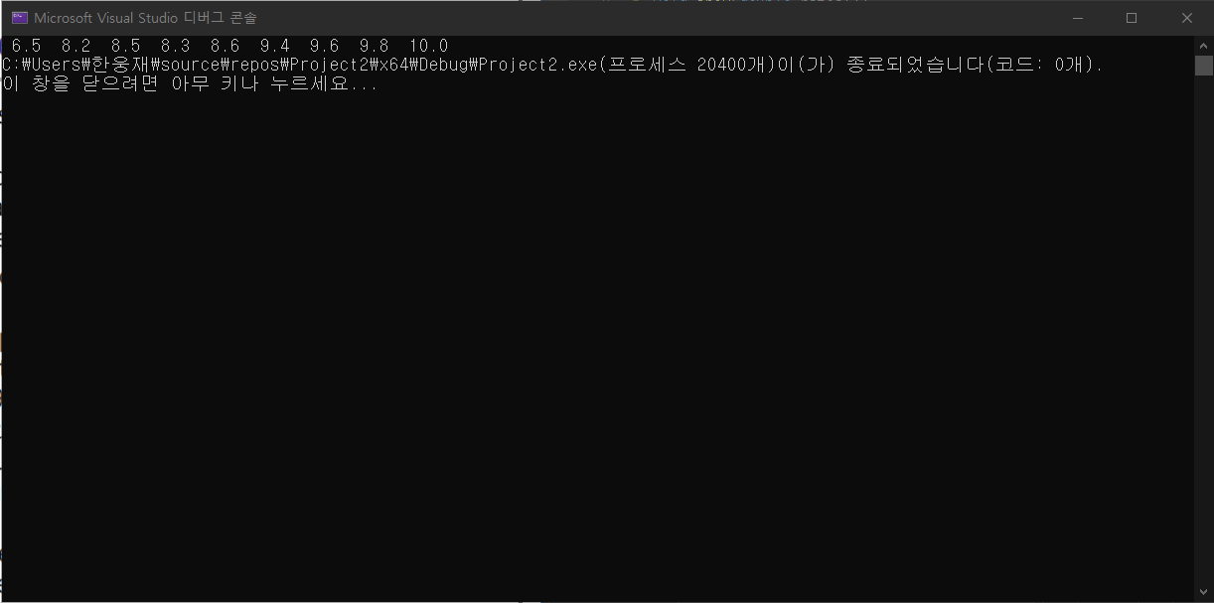

Programming Exercises 4

#define _CRT_SECURE_NO_WARNINGS// or scanf_s

#include <stdio.h>

#include <math.h>

#include <stdlib.h>

#include <string.h>

#include <time.h>

#include <ctype.h>

void extend(double price[], double quantity[], double amount[]);

int main() {

double price[] = { 10.62,14.89, 13.21, 16.55, 18.62, 9.47, 6.58, 18.32, 12.15, 3.98 };

double quantity[] = { 4, 8.5, 6, 8.35, 9, 15.3, 3, 5.4, 2.9, 4.8 };

double amount[10];

extend(price, quantity, amount);

for (int i = 0; i < 10; i++) {

printf("amount[%d] : %lf\n", i, amount[i]);

}

return 0;

}

void extend(double price[], double quantity[], double amount[]) {

for (int i = 0; i < 10; i++) {

amount[i] = price[i] * quantity[i];

}

}

